# LAB # 06

**

**OUTPUT**

**LAB TASKS 2:**

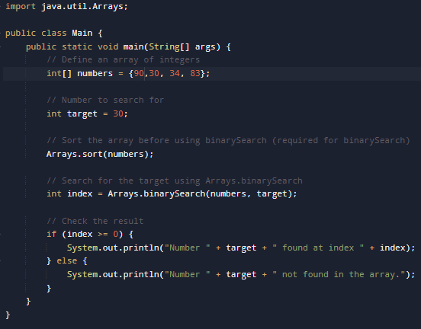

**OUTPUT**

**LAB TASKS 3:**

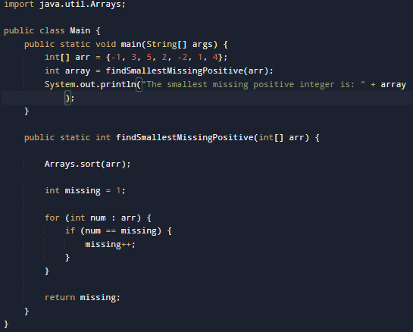

**OUTPUT**

**LAB TASKS 4:**

**OUTPUT**

**HOME TASK 1:**

**OUTPUT**



**HOME TASK 2:**

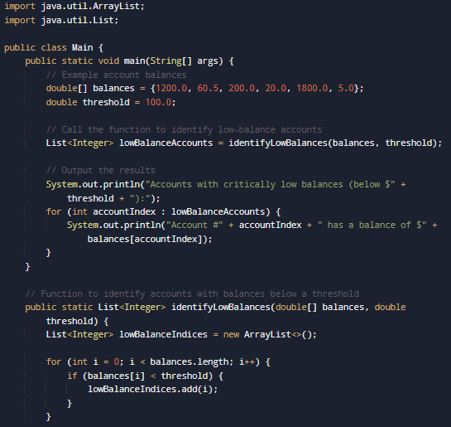

**OUTPUT**

